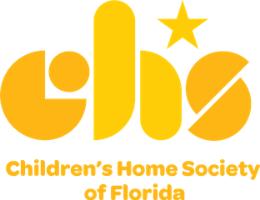
Community Partnership Schools

The Challenge
Thousands of Florida students arrive to school each day with more than a backpack - they carry baggage beyond their years: hunger, homelessness, poverty, exposure to violence, mental health struggles, inadequate access to health care and more. They carry so much weight that they simply cannot focus on their education.

The Solution: Community Partnership Schools
Through a long-term partnership with the school district, a college or university, and a health care provider, CHS leads community collaboration to bring resources and opportunities to students and families. By addressing barriers to learning —poverty, food insecurity, homelessness and others – Community Partnership Schools bring together high-quality academic supports, health care, counseling, mentoring and more – right at the school.

What Makes a Community Partnership School Unique?
Community Partnership Schools are proven to improve student behavior, increase academic gains and graduation rates, and enhance parental involvement. The model helps to provide learning environments that offer equitable opportunities and success for all students.
In addition to being a founding partner of the Community Partnership Schools TM model – along with the University of Central Florida and Orange County Public Schools – CHS is a core partner in 20 Community Partnership Schools from Pensacola to Miami.
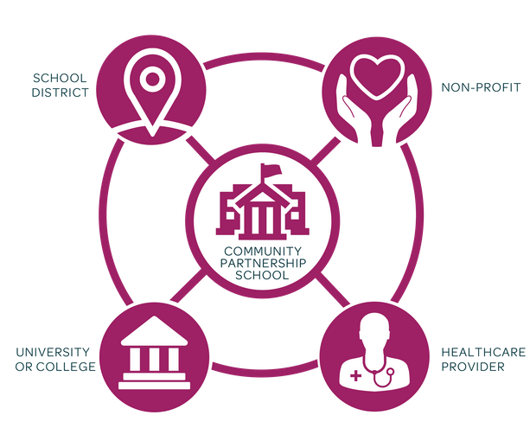
The core of every Community Partnership School is a strong foundation: 4 or more core partners:
School district, reputable non-profit like CHS, health care
provider, college or university.

Long-term commitment:
Partners make a 25-year (or longer) commitment.

Shared decision making:
Governed by a council of representatives from each partner organization,school leadership and community members to make decisions about funding, resource allocation, services and more.

Leveraged resources:
Community Partnership Schools identify and coordinate local providers that can offer academic support programs, enrichment activities and wellness services at the school. By blending and braiding funding from multiple sectors (health, education, human services) we create opportunities in the school and surrounding community to remove barriers to learning and success.

Each Community Partnership School focuses on four pillars:
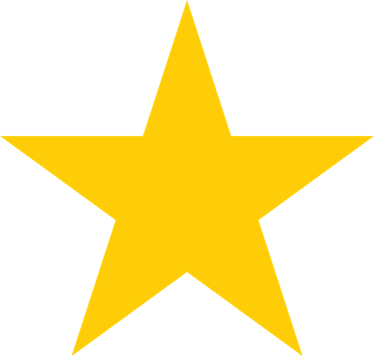 Expanded Learning: Academic support and enrichment take place before and after school, during weekends and in the summer to augment traditional learning during the school day.
Wellness Supports: A range of health and social services are accessible on the school campus.

Family & Community Engagement: Families and the community are partners in children’s education, and the school becomes a neighborhood center offering enrichment opportunities for both students and adults.

Collaborative Leadership: A culture of shared governance and collective decision-making advances a unified vision to identify needs and provide appropriate resources and solutions in the school and community.

Why does this matter?
Every child deserves the opportunity to learn and succeed ... but the reality is that, far too often, a child's zip code and family circumstances determine their future -- and their potential is lost, creating a ripple effect throughout the community.
Community Partnership Schools aim to change that: 87% of students attending Florida’s 26 schools
– 20 of which CHS provides leadership as a core partner – are economically disadvantaged. This ¹ model empowers students to realize their potential and find paths toward academic and life success.

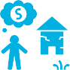
In May 2020, there was an increase of 2.5 million children living in poverty as a result of COVID-19.²

Children who grow up in poverty are five times more likely to drop out of high school. Today, 67 percent of the prison population are high school dropouts.³

21 percent of low-income children and youth aged 6 to 17 have mental health challenges.⁴ Children at risk for mental health challenges in first grade face a 5% drop in academic performance in just two years.⁵

Students with toothaches are almost 4 times more likely to have a low grade point average.⁶

Through the Community Partnership SchoolsTMmodel, students have greater opportunities to thrive. Below is a small snapshot of this impact:

AT OCPS ACADEMIC CENTER FOR EXCELLENCE:
Overall learning gains on Overall learning gains on the FSA MATH increased the FSA ELA* increased from 32% in 2018 from 38% in 2018 to 58%  to 48% in 2019. in 2019.  *FSA ELA = Reading | 71% Disciplinary referrals  dropped from 1,079 in 2018  to 316 in 2019.  reduction in  disciplinary referrals

AT ENDEAVOUR ELEMENTARY:
99% | Almost every single student -- 99% -- at Endeavour Elementary received mental health counseling services in 2020. | The percentage of students making  learning gains in the FSA 67%  ELA* more than tripled  between 2016 and 2019. | 95%  *FSA ELA = Reading

AT EDWARD H. WHITE HIGH SCHOOL:
 | 95% | Graduation rates | 1,000 | Disciplinary
67% |  | increased from 67%  to 95% between 2015  and 2020. |  | referrals dropped  by more than 1,000 from 2016 to 2019.
*Data compiled from 12 Community Partnership Schools reflective of the 2019-2020 school year.
Students received medical, vision and dental services.
4,089
HEALTH & WELLNESS:
1 - Economically disadvantaged students are students determined to be eligible for free and reduced price meals under the National School Lunch Program. 2 - https://firstfocus.org/resources/key-stats-on-the-effect-of-covid-19-on-kids
- - https://www.apa.org/pi/ses/resources/indicator/2013/05/poverty-dropouts
- - https://youth.gov/youth-topics/prevalence-mental-health-disorders-among-youth#:~:text=Youth%20at%20Higher%20Risk%20for,17%20have%20mental%20health%20disorders
- - https://childmind.org/report/2016-childrens-mental-health-report/mental-health-impacts-schools/
- - https://www.ncbi.nlm.nih.gov/pmc/articles/PMC3482021/

Where are we today?

Children's Home Society of Florida serves more than 19,000 students in 20 Community Partnership Schools from Pensacola to Miami

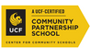Evans High School - Orlando Endeavour Elementary - Cocoa
C.A. Weis Elementary - Pensacola Mort Elementary - Tampa
Edward H. White High School - Jacksonville Howard Bishop Middle School - Gainesville South Woods Elementary - Elkton Webster Elementary - St. Augustine
OCPS Academic Center for Excellence (ACE) K-8 - Orlando Wilkinson Junior High School - Middleburg
Sabal Palm Elementary - Tallahassee
Keystone Heights Jr/Sr High - Keystone Heights Orange Park High School - Orange Park

Dodgertown Elementary - Vero Beach Miami Southridge Sr. High - Miami Manatee Elementary - Bradenton Eccleston Elementary - Orlando Jones High School - Orlando Homestead Middle School - Miami
Four CHS-led Community
Partnership Schools are UCF-Certified

Arthur & Polly Mays Conservatory of the Arts - Miami

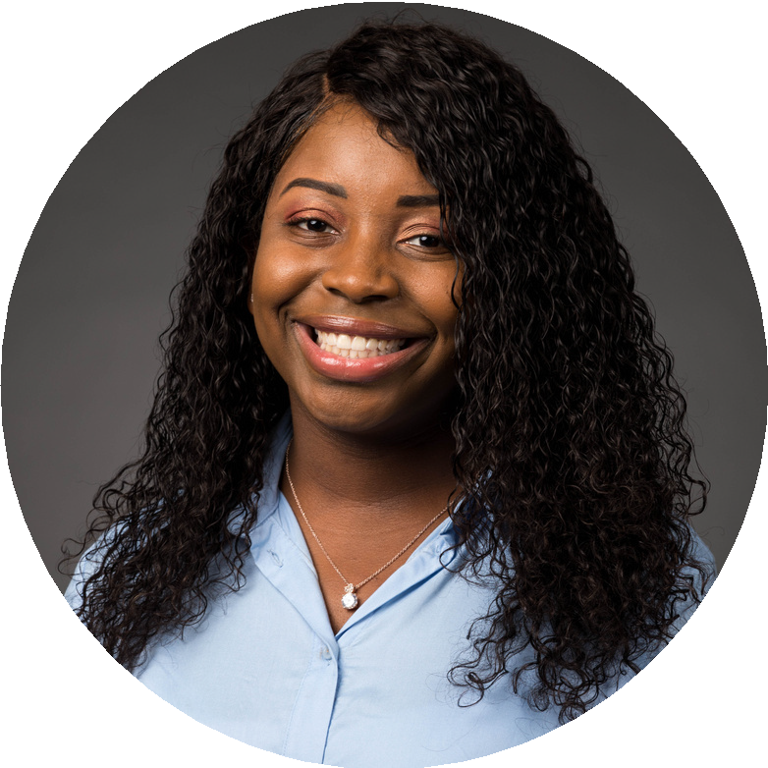Through Community Partnership Schools, children find hope and opportunities. Simply put: they learn how to dream again.

Every child should have the same resources, opportunities and privileges to be what they want to be. Your background, race, economic status and the neighborhood you grew up in does not make you any greater or less – every child can succeed despite the barriers in their way.
Rebecca Boreland
2017 graduate of Evans High, A Community Partnership School Currently attending University of Florida, College of Nursing

For additional information on Community Partnership Schools or to learn how to get involved, contact Jarvis Wheeler, Senior Director, Community Partnership Schools: Jarvis.Wheeler@chsfl.org | 407-463-1706 chsfl.org/communitypartnershipschools

SCHOOL | YEAR EST. | CORE PARTNERS
Evans High School Orlando, FL | 2010 | CHS, Orange County Public Schools, Orange Blossom Family Health, UCF
C.A. Weis Elementary Pensacola, FL | 2015 | CHS, Community Health of Northwest FL, Escambia County School District, UWF
Endeavour Elementary Cocoa, FL | 2016 | Brevard Health Alliance, Brevard Public Schools, CHS, Eastern FL State College, City of Cocoa
OCPS Academic Center for Excellence Orlando, FL | 2016 | CHS, Orange County Public Schools, Orange Blossom Family Health, Rosen Preschool, UCF, Valencia College,
Mort Elementary Tampa, FL | 2016 | CHS, Hillsborough County Public Schools, Tampa Family Health Centers, UNF
Edward H. White High School Jacksonville, FL | 2016 | Agape Community Health Center, Boys & Girls Club of NE FL, CHS, Duval County School District, FSCJ, UNF
Howard Bishop Middle School Gainesville, FL | 2017 | Alachua County School District, Alachua County Health Department, CHS, Santa Fe College, University of Florida
South Woods Elementary Elkton, FL | 2017 | CHS, Flagler Hospital, St. Johns County Public Schools, St. Johns River State College
The Webster School St. Augustine, FL | 2017 | CHS, Flagler Hospital, St. Johns County Public Schools, St. Johns River State College
Wilkinson Jr. High School Middleburg, FL | 2018 | Baptist Health Systems, CHS, Clay County Public Schools, St. Johns River State College
Keystone Heights Jr./Sr. High Keystone Heights, FL | 2018 | Aza Health, CHS, Clay County Public Schools, Santa Fe College
Sabal Palm Elementary Tallahassee, FL | 2018 | CHS, FAMU, FSU Primary Health, Leon County Schools
Dodgertown Elementary Vero Beach, FL | 2019 | CHS, Indian River State College, School District of Indian River County, Treasure Coast Community Health Centers
Eccleston Elementary Orlando, FL | 2019 | CHS, Orange Blossom Family Health, Orange County Public Schools, UCF
Jones High School Orlando, FL | 2019 | CHS, Orange Blossom Family Health, Orange County Public Schools, UCF
Manatee Elementary Bradenton, FL | 2019 | CHS, Manatee County School District, MCR Health, University of South Florida
Orange Park High School Orange Park, FL | 2019 | CHS, Clay County Public Schools, Orange Park Medical Center, Palms Medical Group, St Johns River State College
Miami Southridge Sr. High School Miami, FL | 2020 | CHS, FIU, Miami-Dade County School District
Homestead Middle School Homestead, FL | 2020 | CHS, Community Health of South Florida, FIU Miami-Dade County School District
Arthur & Polly Mays Conservatory of the Arts Miami, FL | 2020 | CHS, FIU, Miami-Dade County Public Schools, Nicklaus Children's Hospital

chsfl.org/communitypartnershipschools

